RESTROOM ASSOCIATION (SINGAPORE)
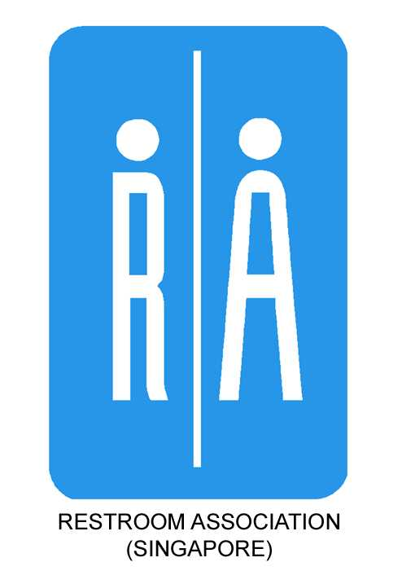
Blk 2, Balestier Road Telephone: 6297 9824
#03-679 Fax: 6297 9825
Singapore 320002 email: info@toilet.org.sg
website: www.toilet.org.sg

SANIGIVER APPLICATION FORM
Please TYPE and complete this registration form and mail/email/fax it back to us.
We will contact you shortly. Thank you!

Name: |  |  |  |  |  | Salutation:
Date of Birth: |  |  |  |  |  | Gender:
Race: |  |  |  |  |  | Age:
Contact Number: |  |  |  |  |  | Occupation:
Email:
Home Address:
Special skills or talents (click or tap to select):
IT Skills (Hardware & Software)  Events Management  Writing  Graphic Design  Fund Raising  Website Design & Maintenance  Training / Development  HR & Administration  Others: |  |  |  |  | Photography  Public Speaking  Arts & Craft  Legal  Education  Research  Publicity  Communication & Network
Please list the skills you wish to learn as a SaniGiver:

Language Proficiency:
Written
English | Chinese |  | Malay | Tamil |  |  | Others:
Spoken
English | Chinese |  | Malay | Tamil |  |  | Others:
Availability and Timing:
Weekly |  | Monthly |  |  | Weekday |  |  | Weekend
Office hours |  | After office hours
Others:
Declaration and Indemnity:

By submitting this form, I declare that all the information given is true and complete.
I am also agreeable to the following:
- Abide by all policies & procedures of the Restroom Association (Singapore) or RAS and will not, in any way, hold the organisation and their working partners liable for any injury, loss, damage, expense and cost that I may sustain, incur or suffer as a result of such services and activities.
- Treat all RAS information as confidential (including pictures and videos of events, etc.) and will not collect, use or disclose them without the permission of the RAS.
- Receive emails, text messages, phone calls, or fax messages comprising/consisting of notices and any publicity materials from the RAS.
- RAS to take photos and videos of me at its events to be publicised in any form of online and print media including its own publicity materials.

For Official Use Only
Date received:
Interviewed by:
Interview date:
Remarks:

