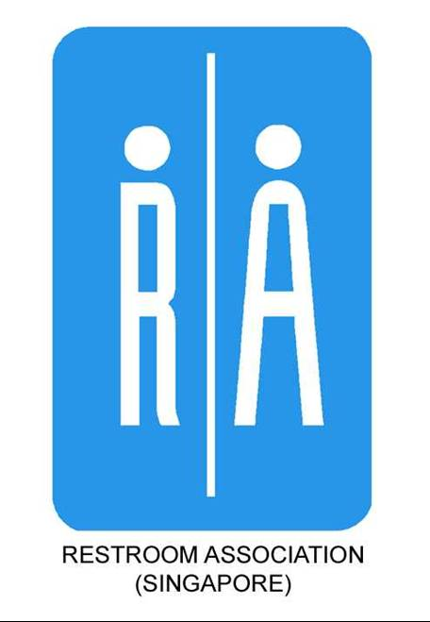

Sustaining Toilets As Restrooms (STAR) Awards Programme

Application Form
Name and Address of Participating School:
Person in-charge:
Tel: | H/P: | Fax: | Email:
COMPONENTS: (select at least ONE of (A), (B) & (C) below)

(A) EDUCATION & AWARENESS

Assembly Talk(s)  (20 to 30 minutes) | Date(s) & Timing(s): (earliest is 10am, 10 working days in advance)
Project Workshop(s)  (20 to 45 minutes) | Date(s) & Timing(s): (at least 10 working days in advance)  Types of Projects (select at least ONE potential projects)  Decorating / enhancing the washrooms  Cleaning attendants’ appreciation activities  Creating educational/awareness material for an exhibition  Conducting surveys or case studies  Creating videos or web content  Inspecting their own washrooms and providing feedback  Holding assembly talks in school or at other community establishments  Any other project that relates to restroom cleanliness and hygiene awareness  For project details, please visit www.toilet.org.sg/projects1_2.html#PROJECTS

(B) MAINTENANCE & SERVICE

Submission of cleaning attendants’ certificates (WSQ or NSRS) in WASHROOM CLEANING by:
Hand (only applicable if (A) and/or (C) is selected)
Email to info@toilet.org.sg with email subject "NAME OF SCHOOL - STAR CLEANER CERTIFICATES“
Fax to 6297 9824 with "NAME OF SCHOOL - STAR CLEANER CERTIFICATES“ written on every page

(C) DESIGN & STANDARDS

Restroom Audit Date & Time: (at least 10 working days in advance)

Applicant’s Declaration:

I declare that the above information is correct.

Date of Application:

Signature of Applicant & School Stamp: ___________________________________________________
For enquiries, please contact:
Tel: 6297 9824
Fax: 6297 9825
E-mail: info@toilet.org.sg
URL: www.toilet.org.sg

Please send application to:
Restroom Association (Singapore)
Blk 2, Balestier Road
#03-679 Singapore 320002
E-mail: info@toilet.org.sg

