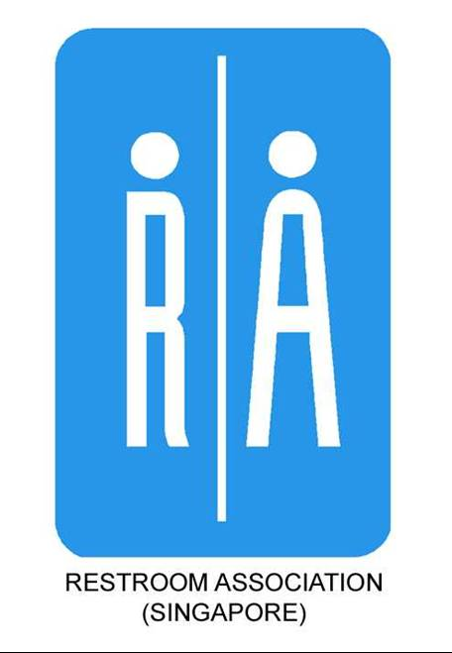
Happy Toilets @ Preschools Programme

Application Form for New Assessment/ Re-Assessment
Name of Participating Preschool:
Address of Participating Preschool:
Person in-charge:
Tel: | H/P: |  | Email:
New Assessment - $150 |  | Re-assessment - $100
(A) DESIGN

Assessment of Water Closets, Urinals & Showers

(B) MAINTENANCE

Training Session for Cleaning Attendant

(C) EDUCATION
i) Preschoolers Talk / Activity
ii) Teachers Workshop
iii) Parents Talk (Only for re-assessment / 2nd year)

Name to appear on certificate:

Applicant’s Declaration:

I declare that the above information is correct. I have read and understood the terms and conditions governing the administration of the Happy Toilets @ Preschools Programme.

Date of Application:

Signature of Applicant & Company Stamp: ___________________________________________________

For enquiries, please contact:
Tel: 6297 9824
Fax: 6297 9825
E-mail: info@toilet.org.sg
URL: www.toilet.org.sg

Please send application to:
Restroom Association (Singapore)
Blk 2, Balestier Road
#03-679 Singapore 320002
E-mail: info@toilet.org.sg

TERMS AND CONDITIONS UNDER THE HAPPY TOILETS @ PRESCHOOL PROGRAMME

The following are the terms and conditions the Participating Preschool has agreed to abide:

1. RAS reserves the right to reject any application form if:

(a) the application is incomplete or has not been completed correctly; or
(b) any information furnished therein is false.

2. In the course of assessment, RAS’ duly appointed assessor may request the Participating Preschool to produce documentary proof, e.g. restroom maintenance records etc as part of the assessment exercise. Photocopies of the documents may be kept by RAS for record purposes.

3. Any appeal against an assessment should be addressed in writing to the RAS within 14 days from the date of notification of results. A fee of $30 shall be payable for the reassessment.

4. Participating Preschool shall take steps to uphold the standards according to the standards awarded at all times throughout the duration of 1 year after the issuance of the certificate.

5. RAS reserves the right to withdraw any certificate issued if there is a breach of terms and conditions herein. Under such circumstances, Participating Preschool or RAS shall remove the award or plaque displayed at the restroom upon notification by RAS in writing.

6. RAS reserves the right to review its assessment criteria and the terms and conditions herein in subsequent assessment or reassessment exercises as and when necessary to stay current and relevant.

7. Participating Preschool shall hold RAS harmless and indemnified against all actions, claims and demands in respect of any loss, injury or damage occasioned to any person or property arising from or in connection with the award, and the display of the award or plaque at the restroom.

8. Participating Preschool shall consent RAS to the use of any photos taken for the assessment, to be publicised in any form of online and print media including RAS’ own publicity materials.

INTEPRETATION

In these terms and conditions, the following words and expressions shall have the meanings set hereunder unless the context otherwise requires:

“RAS” means The Restroom Association (Singapore)

“Participating Preschool” means any person or preschool responsible for participating in the Happy Toilets @ Preschools Programme and has applied to RAS for an assessment.

“Application” means an application to RAS made in such manner or otherwise acceptable to RAS for the assessment or re-assessment or preschool toilets by the participating preschool through the prescribed Happy Toilets @ Preschools programme.

TERMS AND CONDITIONS UNDER THE HAPPY TOILETS @ PRESCHOOL PROGRAMME

The following are the terms and conditions the Participating Preschool has agreed to abide:

1. RAS reserves the right to reject any application form if:

(a) the application is incomplete or has not been completed correctly; or
(b) any information furnished therein is false.

2. In the course of assessment, RAS’ duly appointed assessor may request the Participating Preschool to produce documentary proof, e.g. restroom maintenance records etc as part of the assessment exercise. Photocopies of the documents may be kept by RAS for record purposes.

3. Any appeal against an assessment should be addressed in writing to the RAS within 14 days from the date of notification of results. A fee of $30 shall be payable for the reassessment.

4. Participating Preschool shall take steps to uphold the standards according to the standards awarded at all times throughout the duration of 1 year after the issuance of the certificate.

5. RAS reserves the right to withdraw any certificate issued if there is a breach of terms and conditions herein. Under such circumstances, Participating Preschool or RAS shall remove the award or plaque displayed at the restroom upon notification by RAS in writing.

6. RAS reserves the right to review its assessment criteria and the terms and conditions herein in subsequent assessment or reassessment exercises as and when necessary to stay current and relevant.

7. Participating Preschool shall hold RAS harmless and indemnified against all actions, claims and demands in respect of any loss, injury or damage occasioned to any person or property arising from or in connection with the award, and the display of the award or plaque at the restroom.

8. Participating Preschool shall consent RAS to the use of any photos taken for the assessment, to be publicised in any form of online and print media including RAS’ own publicity materials.

INTEPRETATION

In these terms and conditions, the following words and expressions shall have the meanings set hereunder unless the context otherwise requires:

“RAS” means The Restroom Association (Singapore)

“Participating Preschool” means any person or preschool responsible for participating in the Happy Toilets @ Preschools Programme and has applied to RAS for an assessment.

“Application” means an application to RAS made in such manner or otherwise acceptable to RAS for the assessment or re-assessment or preschool toilets by the participating preschool through the prescribed Happy Toilets @ Preschools programme.

