Audit will be conducted within
10 working days from the
date of application
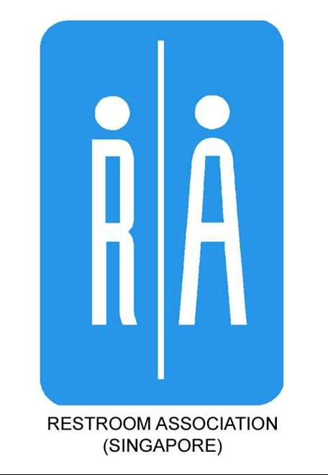 Happy Toilet Programme

Application Form for New Assessment/ Re-Assessment
Name and Address of Organisation:
Person in-charge:
Tel: | H/P: |  | Fax: | Email:
New Assessment |  | Re-assessment, Last Date of Audit:
Fees:

(i) Less than 20 toilets:
Areas | Unit Price | Male |  |  |  |  | Female |  |  |  |  | Total No. of Units x Unit Price = Total Amount
 |  | Floor Level |  |  |  |  | Floor Level
Cubicle(s) with toilet bowl/shower | $20
*General area(s) | $50
Toilet(s) with more than 2 urinals | $20
Stand-alone handicap unit(s) | $25
Certificate(s) | $15
*Note: General area includes wash area/basin, mirror and two urinals |  |  |  |  |  |  |  |  | Total fees

Less than 20 toilets, minimum fee is $250 and minimum $120 per toilet is applicable for 3-year participation

(ii) 20 to 39 toilets - $120 each / $100 each for 3-year participation

(iii) 40 and above - $110 each / $90 each for 3-year participation

Total no. of toilets at $ each. Total fees $ * Select “N/A” for 1-Year Participation
Name to appear on certificate:

*Note: “Male & Female Restrooms” would be indicated if it is a shared certificate

Applicant’s Declaration:

I declare that the above information is correct. I have read and understood the terms and conditions governing the administration of the Happy Toilet Programme.

Date of Application:

Signature of Applicant & Company Stamp: ___________________________________________________
Please send application & payment to:
Restroom Association (Singapore)
Blk 2, Balestier Road
#03-679 Singapore 320002
For enquiries, please contact:
Tel: 6297 9824
Fax: 6297 9825
E-mail: info@toilet.org.sg
URL: www.toilet.org.sg

TERMS AND CONDITIONS UNDER THE HAPPY TOILET PROGRAMME

The following are the terms and conditions the Restroom Owner has agreed to abide:

1. RAS reserves the right to reject any application form if:

(a) the application is incomplete or has not been completed correctly; or
(b) any information furnished therein is false.

2. In the course of assessment, RAS’s duly appointed assessor may request the Restroom Owner to produce documentary proof, e.g. restroom maintenance records etc as part of the assessment exercise. Photocopies of the documents may be kept by RAS for record purposes.

3. Any appeal against an assessment should be addressed in writing to the Restroom Association of Singapore (RAS) within 14 days from the date of notification of results. A fee of $50 per toilet shall be payable for the reassessment.

4. Restroom Owner shall take steps to uphold the standards according to the “Happy Toilet” standards awarded at all times throughout the duration of 1 year after the issuance of the certificate.

5. RAS reserves the right to withdraw any certificate issued if there is a breach of terms and conditions herein. Under such circumstances, Restroom Owner or RAS shall remove the award or plaque displayed at the restroom upon notification by RAS in writing.

6. RAS reserves the right to review the elements in the “Happy Toilet Programme Grading Checklist” and the terms and conditions herein in subsequent assessment or reassessment exercises as and when necessary to stay current and relevant.

7. Restroom Owner who participates in the three-year Happy Toilet Programme shall commit for a period of three years upon application. In the event that the Restroom Owner wishes to opt out of the Happy Toilet Programme in the second or third year, the Restroom Owner is liable to pay the difference between the actual fees (fees for less than 20 toilets or 20 to 39 toilets or above 40 toilets) and the 3-Year Participation fees.

8. Restroom Owner shall hold RAS harmless and indemnified against all actions, claims and demands in respect of any loss, injury or damage occasioned to any person or property arising from or in connection with the award, and the display of the award or plaque at the restroom.

9. Restroom Owner shall consent RAS to the use of any photos taken for the assessment, to be publicised in any form of online and print media including RAS’ own publicity materials.

INTEPRETATION

In these terms and conditions, the following words and expressions shall have the meanings set hereunder unless the context otherwise requires:

“RAS” means The Restroom Association of Singapore

“Restroom Owner” means any person or organization responsible for the maintenance and up-keeping of public toilet facilities and has applied to RAS for a public toilet inspection/ grading.

“Happy Toilet” refers to the grading scheme managed by the RAS in which public toilet facilities are graded on a set of criteria deemed appropriate by the RAS. These criteria may be subject to changes and are at the discretion of RAS.

“Application” means an application to RAS made in such manner or otherwise acceptable to RAS for the assessment or re-assessment or public toilets by the restroom owner through the prescribed “Happy Toilet” programme.

“Happy Toilet Programme Grading Checklist” refers to an identified list of set criteria upon which participants of the programme will be assessed on. RAS reserves the rights to amend or modify these criteria as required.

